
Taizhou Creating Bio-pharm Co. ,Ltd.

ADD: 715 Room,Unit A.Junyue Building,Taizhou ,Zhejiang,China

TEL:0086-576-88827176

FAX:0086-576-88822496

分析证明书

CERTIFICATE OF ANALYSIS
Product name: Bleomycin sulphate硫酸博莱霉素
Batch no. 批 号:20241101 | Quantity 数 量: 100gr
Manuf. date 生产日期: 2024/11/25 | Expiry date 有 效 期: 2026/11/24

ITEMS | STANDARD | RESULTS
Appearance | White to off-white amorphous powder | Off-white amorphous powder
Identification | - IR  - Reaction of Sulfate | Conforms  Conforms
Copper | ≤0.1% | 0.0%
PH | 4.5 ~ 6.0 | 4.9
Loss on Dryings | ≤6.0% | 3.1%
Potency | 1.5~2.0U/mg | 1.71U/mg
Content of Bleomycins  Bleomycin A2  Bleomycin B2  Bleomycin A2+ B2  Bleomycin B4 | 55%~70%  25%~32%  ≥90%  ≤1.0% | 65.8%  30.5%  96.3%  ＜0.6%
Residual Solvents  Acetone  Ethanol | ≤20000ppm  ≤5000ppm | 8500ppm  1150ppm
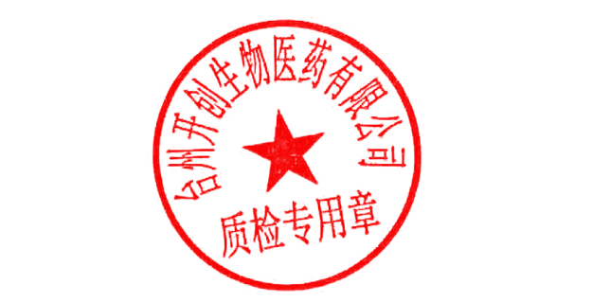
CONCLUSION: The results conform to USP specification.

复核人Checker: 化验人Analyst:

