
Taizhou Creating Bio-pharm Co. ,Ltd.

ADD: 715 Room,Unit A.Junyue Building,Taizhou ,Zhejiang,China

TEL:0086-576-88827176

FAX:0086-576-88822496

分析证明书

CERTIFICATE OF ANALYSIS
Product name品名: Mirogabalin besylate米洛巴林苯磺酸 CAS NO.:1138245-21-2
Batch no. 批 号:20241201 | Quantity 数 量:1.22KG
Manuf. date 生产日期: 2024/12/16 | Expiry date 有 效 期: 2026/12/15

Items | Specifications | Results
Appearance | White to off-white solid powder | Off-white solid powder
Related substance | Impurity F ≤ 0.15% | 0.02%
Related substance | Impurity N and O ≤ 0.15% | 0.01%
Related substance | Impurity P ≤ 0.15% | 0.05%
Related substance | Impurity R ≤ 0.15% | ND
Related substance | Impurity S ≤ 0.15% | ND
Related substance | Impurity T ≤ 0.15% | ND
Related substance | Impurity U ≤ 0.15% | ND
Related substance | Impurity V ≤ 0.15% | ND
Related substance | Other single impurity ≤ 0.1% | 0.03%
Related substance | Total impurities ≤ 1.0 | 0.23%
Water | ≤0.5% | 0.38%
Residue on ignition | ≤0.1% | 0.05%
Residual solvents | Tetrahydrofuran≤720ppm | ND
Residual solvents | Ethanol≤5000pp | ND
Residual solvents | Ethyl acetate≤ 5000pp | ND
Residual solvents | Methyl teritiary butyl ether≤ 5000ppm | ND
Residual solvents | Acetonitrile≤ 410ppm | ND
Purity(HPLC) | 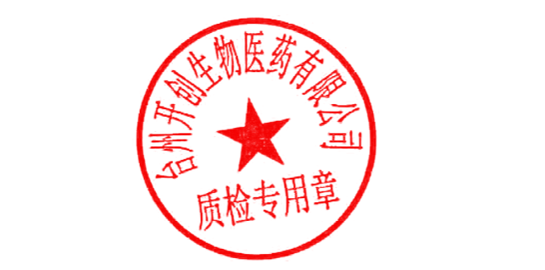  98.0%~102.0%(on anhydrous) | 99.7%

Conclusion:The product tested complies with the specifications.

复核人Checker: 化验人Analyst:

