 | 武汉福鑫化工有限公司Wuhan Fortuna Chemical Co.,Ltd
Address: Room 2015-2016,No.2 Building,Kaixin Mansion,No.107 Jinqiao Avenue,Wuhan,China.
Website: www.fortunachem.com Tel：027-85767163, 027-59207850 E-mail: purchase@fortunachem.com
CERTIFICATE OF ANALYSIS
Products Name | CAS NO. | Batch No.
Sodium poly[(naphthaleneformaldehyde)sulfonate] | 9084-06-4 | 20240620
Mfg. Date | Exp. Date | Package
Jun.,20,2024 | Jun., 19,2026 | 25kg/ Box/Bag/Drum

Items | Specifications | Results
Appearance | Deep brown powder | Deep brown powder
Compose | Methylnaphthalene sulfonate formaldehyde condensate
Ion type | Negative ion
Solubility | Easy dissolve in water
Content% | ≥92 | 93
Disperse power(standard product),% | ≥80 | 83
Heat-resisting stability | 130 degree | 4-5
Sodium sulfate content,% | ≤ 20 | 19
PH value(1% water-solution) | 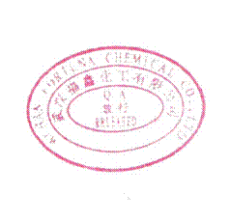  7-9 | 7.8
Content of calcium and magnesium  ion% | ≤ 0.4 | 0.2
Insolubles in water, % | ≤ 0.05 | 0.02
Conclusion | Qualified

Q.C.: Luo Xiaofeng Tester: AT02 Re-tester: AT03

