 CERTIFICATE OF ANALYSIS
COA No.:HL08202406281
Product Name | Sodium taurodeoxycholate hydrate
CAS Registry number | 207737-97-1
Structure | 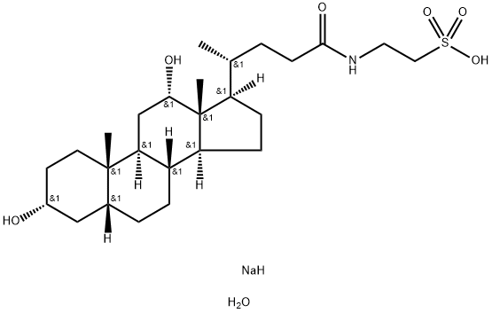
Batch number | 202405201
Date of manufacture | 20240520

Index Name | Specifications | Results
Appearance | White powder with strong moisture  absorption | White powder with strong  moisture absorption
TLC | TLC is consistent with the reference  substance | Conforms
Purity | 97.0% min | 98.2%
Water | 8.0%max | 4.8%
Heavy Metal | 10ppm max | 6ppm
Residue on ignition | 4.0%-6.0% | 4.9%
Water Solubility | Clarified free of sediment | Conforms
Conclusion | Conforms to Eneterprise standard

