 | 武汉福鑫化工有限公司Wuhan Fortuna Chemical Co.,Ltd
Address: Room 2015-2016,No.2 Building,Kaixin Mansion,No.107 Jinqiao Avenue,Wuhan,China.
Website: www.fortunachem.com Tel：027-85767163, 027-59207850 E-mail: sales@fortunachem.com
CERTIFICATE OF ANALYSIS
Products Name | CAS NO. | Batch No.
Ovalbumin Egg | 9006-59-1 | 20231215
Mfg. Date | Exp. Date | Package
Dec.,15,2023 | Dec., 14,2025 | 100g/Foil Bag

ITEMS | SPECIFICATIONS | RESULTS
Appearance | Light yellow lyophilized powder | Conform
Solution Color | 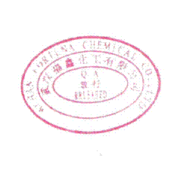  Colorless to light yellow | Conform
Turbidity(50mg/ml water) | Clear | Conform
Loss on Drying | ≤5% | Conform
Nitrogen content | 13～16% | Conform
Protein level | ＞85% | Conform
Conclusion | QUALIFIED.

Q.C.: Luo Xiaofeng Tester: AT02 Re-tester: AT03

