质量报告 Certificate of Analysis
产品名称  Product Names | 神经酰氨NP2-Ceramide NP2 | CAS No. | 100403-19-8
产品批号  Batch No. | TH077NP2-202404-22 | 报告日期  Report Date | 2024-04-28
产品编号 | TH-NP2-0772
生产日期  Manufacturing Date | 2024-04-22 | 有效期  Expiry Date | 2026-04-28
检验依据 Inspection basis | 企业标准Enterprise Standard
分析项目  Item of Analysis | 质量标准  Specification | 检测结果  Results
CAS NO。： | 100403-19-8 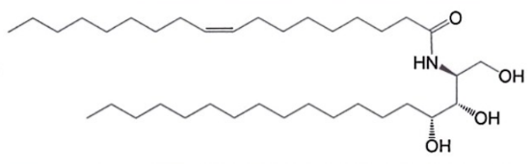
外观  Appearance | 白色结晶性粉末  White to off-white powder | 白色结晶性粉末  White powder
纯度（面积归一法）  Purity | NLT90% | 97%
含量（外标法）  Aaasy (External standard) | NLT90% | 96.1%
气味  Odor | 特征性气味  Characteristic odor | 符合规定  Complies
熔点  Melting range | 98.0~110.0℃ | 99.4℃
Ethyl oleate  油酸乙酯 | NMT3000PPM  ≤3000ppm | 未检出  N.D
干燥失重  Loss on drying | ≤1.0% | 0.7%
甲醇  Methanol | NMT2000ppm  ≤2000ppm | 未检出  N.D
重金属  Heavy Metals | ≤20ppm | 符合规定  Complies
需菌氧总数  Total aerobic bacteria | ≤1000 CFU/g | ＜10 CFU/g
霉菌和酵母菌  Mold and yeast | ≤100 CFU/g | ＜10 CFU/g
This product meets the above indicator requirements

